**How Do I Share My Screen?**

**Overview**Zoom allows for screen sharing on desktop, tablet and mobile devices running Zoom.

* The host and attendee can screen share by clicking the **Share Screen** icon.
* The host does not need to "pass the ball" or "make someone else a presenter" to share.
* The host can "lock screen share" so no attendee can screen share.

**Sharing your Screen**

1. Click the**Share Screen** button located in your meeting controls.  
   https://assets.zoom.us/images/en-us/desktop/generic/share-screen-button.png
2. Select the screen you want to share. You can also choose an individual application that is already open on your computer, the desktop, a whiteboard, or an iPhone/iPad.  
   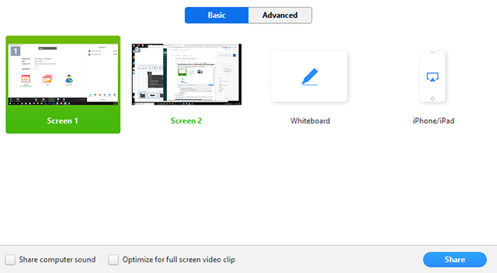
3. (Optional) Enable these features:
   * Check **Share Computer Sound**: If you check this option, any sound played by your computer will be shared in the meeting.
   * Check **Optimize for full screen video clip**: Check this if you will be sharing a video clip in full screen mode. Do not check this otherwise, as it may cause the shared screen to be blurry.
4. Click **Share**.

**Share Screen Menu**

When you start sharing your screen, the meeting controls will move into a menu that you can drag around your screen.

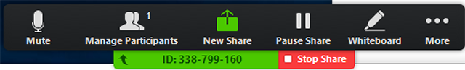

* **Mute/Unmute**: Mute or unmute your microphone.
* **Start/Stop Video**: Start or stop your in-meeting video.
* **Participants/Manage Participants**: View or manage the participants (if the host).
* **New Share**: Start a new screen share. You will be prompted to select which screen you want to share again.
* **Pause Share**: Pause your current shared screen.
* **Annotate** / **Whiteboard**: Display annotation tools for drawing, adding text, etc.
* **More**: Hover over more for additional options.  
  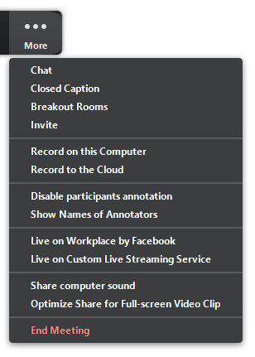
  + **Chat**: Open the chat window.
  + **Invite**: Invite others to join the meeting.
  + **Record**: Start recording locally or to the cloud.
  + **Allow/Disable participants annotation**: Allow or prevent the participants from annotating on your shared screen.
  + **Show/Hide Names of Annotators**: Show or hide the participants' name when they are annotating on a screen share. If set to show, the participant's name will briefly display beside their annotation.  
    https://assets.zoom.us/images/en-us/desktop/generic/in-meeting/annotator-name.png
  + **Live on Workplace by Facebook**: Share your meeting or webinar on Workplace by Facebook. Learn more about live-streaming a webinar. Learn more about live-streaming a meeting.
  + **Optimize Share for Full-screen Video Clip:** Start optimizing for a video clip in full screen mode.   
    **Note**: Do not enable this setting if you are not sharing a full screen video clip, as it will blur your screen share.
  + **End Meeting:** Leave the meeting or end the meeting for all participants.

# 

# Managing Participants in a Meeting

## Overview As the host in a meeting, you can manage the participants. By default, any participant in a meeting can share their video, screen, and audio. If you want to limit who can share their screen, video, and audio, we recommend using the webinar platform.

With meetings, hosts and co-hosts can control the following features:

* Mute participants
* Request that a participant unmutes
* Stop a participant's video
* Request that a participant starts their video
* Prevent participants from screen sharing
* Rename a participant
* Put a participant on hold if enabled
* Choose to play an enter or exit chime
* Lock the meeting to prevent anyone new from joining
* Place participants in waiting room or admit/remove participants from the waiting room (waiting room can only be enabled by the host)

Only hosts have access to these features:

* Give a participant the ability to record locally
* Make a participant host or co-host
* Enable waiting room

## Manage participants

Click **Manage Participants** in the host controls to display the participants list:

https://assets.zoom.us/images/en-us/desktop/generic/manage-participants-button.png

Click the drop-down menu located at the top-left corner to close the participants list or click **Pop Out** to separate the participants list from the meeting window:

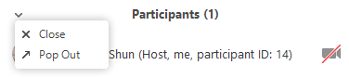

Hover over a participant and click **More** for these options:

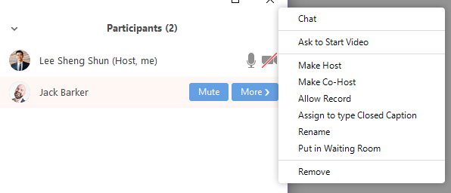

* **Chat**: Open the chat window to send messages directly to the panelist.
* **Stop Video**: Stop the participant's video stream so they are unable to start their video. If the participant hasn't started their video, you will see the **Ask to Start Video** option.
* **Make Host** (only available to the host): Assign the attendee to be the host. There can only be one host.
* **Make Co-Host** (only available to the host): Assign the attendee to be a co-host. You can have an unlimited number of co-hosts.
* **Allow Record** (only available to the host): Allow the attendee to start or stop a local recording of the meeting. Attendees do not have access to start a cloud recording.
* **Assign to type Closed Caption** (only available to the host): Assign the attendee to type Closed Caption during the meeting.
* **Rename**: Change the attendee name that is displayed to other participants.  
  **Note**: To change your own name that is displayed, hover over your name in the participants list and click **Rename**. This change only applies to the meeting.
* **Put in Waiting Room:** Place the attendee in a virtual waiting room while you prepare for the meeting. The host must enable waiting room for this option to appear.
* **Put On Hold**: If the waiting room is not enabled, you'll see this option to place the attendee on hold.
* **Remove**: Dismiss a participant from the meeting. They won't be able to rejoin unless you allow participants and panelists to rejoin.

You will also have access to enable or disable these options at the bottom of the participants list:

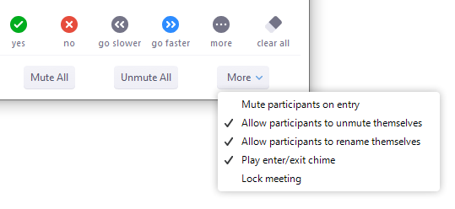

* **Mute All** / **Unmute All**: Mute or unmute all participants in meeting.
* **Mute participants on entry**: Automatically mute participants as they join the meeting.
* **Allow participants to unmute themselves**: Participants can unmute themselves if they want to speak to others in the meeting.
* **Allow participants to rename themselves**: Participants can change their screen name displayed to other participants.
* **Play enter/exit Chime**: Play a sound when participants join and leave the meeting
* **Lock meeting**: Don't allow other participants to join the meeting in progress.
* **Merge to meeting window**: Merge the participants list with the main meeting window. This option is only available if you separated the participants list from the main meeting window.

## Prevent participants from screen sharing

1. In the host controls, click the arrow next to **Share** **Screen** and click **Advanced Sharing Options**.  
   https://assets.zoom.us/images/en-us/desktop/generic/share-screen-button.png
2. Under **Who can share?** choose **Only Host**.
3. Close the window.